**Week of May 27- June 02**

This report covers all the tweets sent between May 27 – June 02 that used the hashtag #VAsen

##### How many are retweets?  
   
 table(VA.tweetdf$isRetweet)

##   
## FALSE TRUE   
## 33 246

The conversation was dominated by retweets, accounting for 246 out of 279, or 88%, of the total tweets.

**Top Tweets using the Hashtag #VASen**

The following is an output of all the top 6 tweets with the most favorites and the most retweets in the tweets collection. Although the order is different, the same tweets made it in both lists. A screenshot of the tweets are below for visualization.

### List of top 6 favorite retweets

## text  
## 1 Huge support Saturday at our "Rally to Support President Trump's Agenda" in Loudoun! \n\nVote June 12th to defeat rad… https://t.co/OA98PelqOd  
## 2 Here's Some TRUE conservatives I love \xed\xa0\xbc\xed\xb7\xba\xed\xa0\xbc\xed\xb7\xb8\n\n.@tedcruz \n.@senatormcdaniel \n.@Nick4House \n.@NickForVA \n\nALL are willin… https://t.co/71PpH8uH4O  
## 3 I met an awesome supporter at our Rally to Defeat MS-13 in Fairfax! A Caps fan too! Go Caps!!\n\n#ALLCAPS\n\n#VASen https://t.co/IV8NPB1zVK  
## 4 This is what happens when you elect Republicans who don’t have a backbone, who don’t stand up for anything. Most of… https://t.co/Cg2POnRCG1  
## 5 The Virginia team recruits over 100 new COS supporters! https://t.co/fdojaBf6ps #vasen #valeg #virginia #vapol  
## 6 .@NickForVA knows how we can provide the necessary narrative we need to push for and get free-market healthcare bet… https://t.co/djyW6m3IST  
## favoriteCount created screenName  
## 1 96 2018-05-27 14:04:28 CoreyStewartVA  
## 2 88 2018-05-30 18:39:29 deeg25  
## 3 79 2018-06-02 22:04:44 CoreyStewartVA  
## 4 59 2018-06-01 14:13:44 CoreyStewartVA  
## 5 39 2018-06-01 16:41:22 COSProject  
## 6 34 2018-05-31 13:00:31 michael__1776

# top 6 retweeted tweets

## text  
## 1 Here's Some TRUE conservatives I love \xed\xa0\xbc\xed\xb7\xba\xed\xa0\xbc\xed\xb7\xb8\n\n.@tedcruz \n.@senatormcdaniel \n.@Nick4House \n.@NickForVA \n\nALL are willin… https://t.co/71PpH8uH4O  
## 2 Huge support Saturday at our "Rally to Support President Trump's Agenda" in Loudoun! \n\nVote June 12th to defeat rad… https://t.co/OA98PelqOd  
## 3 I met an awesome supporter at our Rally to Defeat MS-13 in Fairfax! A Caps fan too! Go Caps!!\n\n#ALLCAPS\n\n#VASen https://t.co/IV8NPB1zVK  
## 4 This is what happens when you elect Republicans who don’t have a backbone, who don’t stand up for anything. Most of… https://t.co/Cg2POnRCG1  
## 5 .@NickForVA knows how we can provide the necessary narrative we need to push for and get free-market healthcare bet… https://t.co/djyW6m3IST  
## 6 The Virginia team recruits over 100 new COS supporters! https://t.co/fdojaBf6ps #vasen #valeg #virginia #vapol  
## retweetCount created screenName  
## 1 69 2018-05-30 18:39:29 deeg25  
## 2 51 2018-05-27 14:04:28 CoreyStewartVA  
## 3 33 2018-06-02 22:04:44 CoreyStewartVA  
## 4 27 2018-06-01 14:13:44 CoreyStewartVA  
## 5 26 2018-05-31 13:00:31 michael__1776  
## 6 21 2018-06-01 16:41:22 COSProject

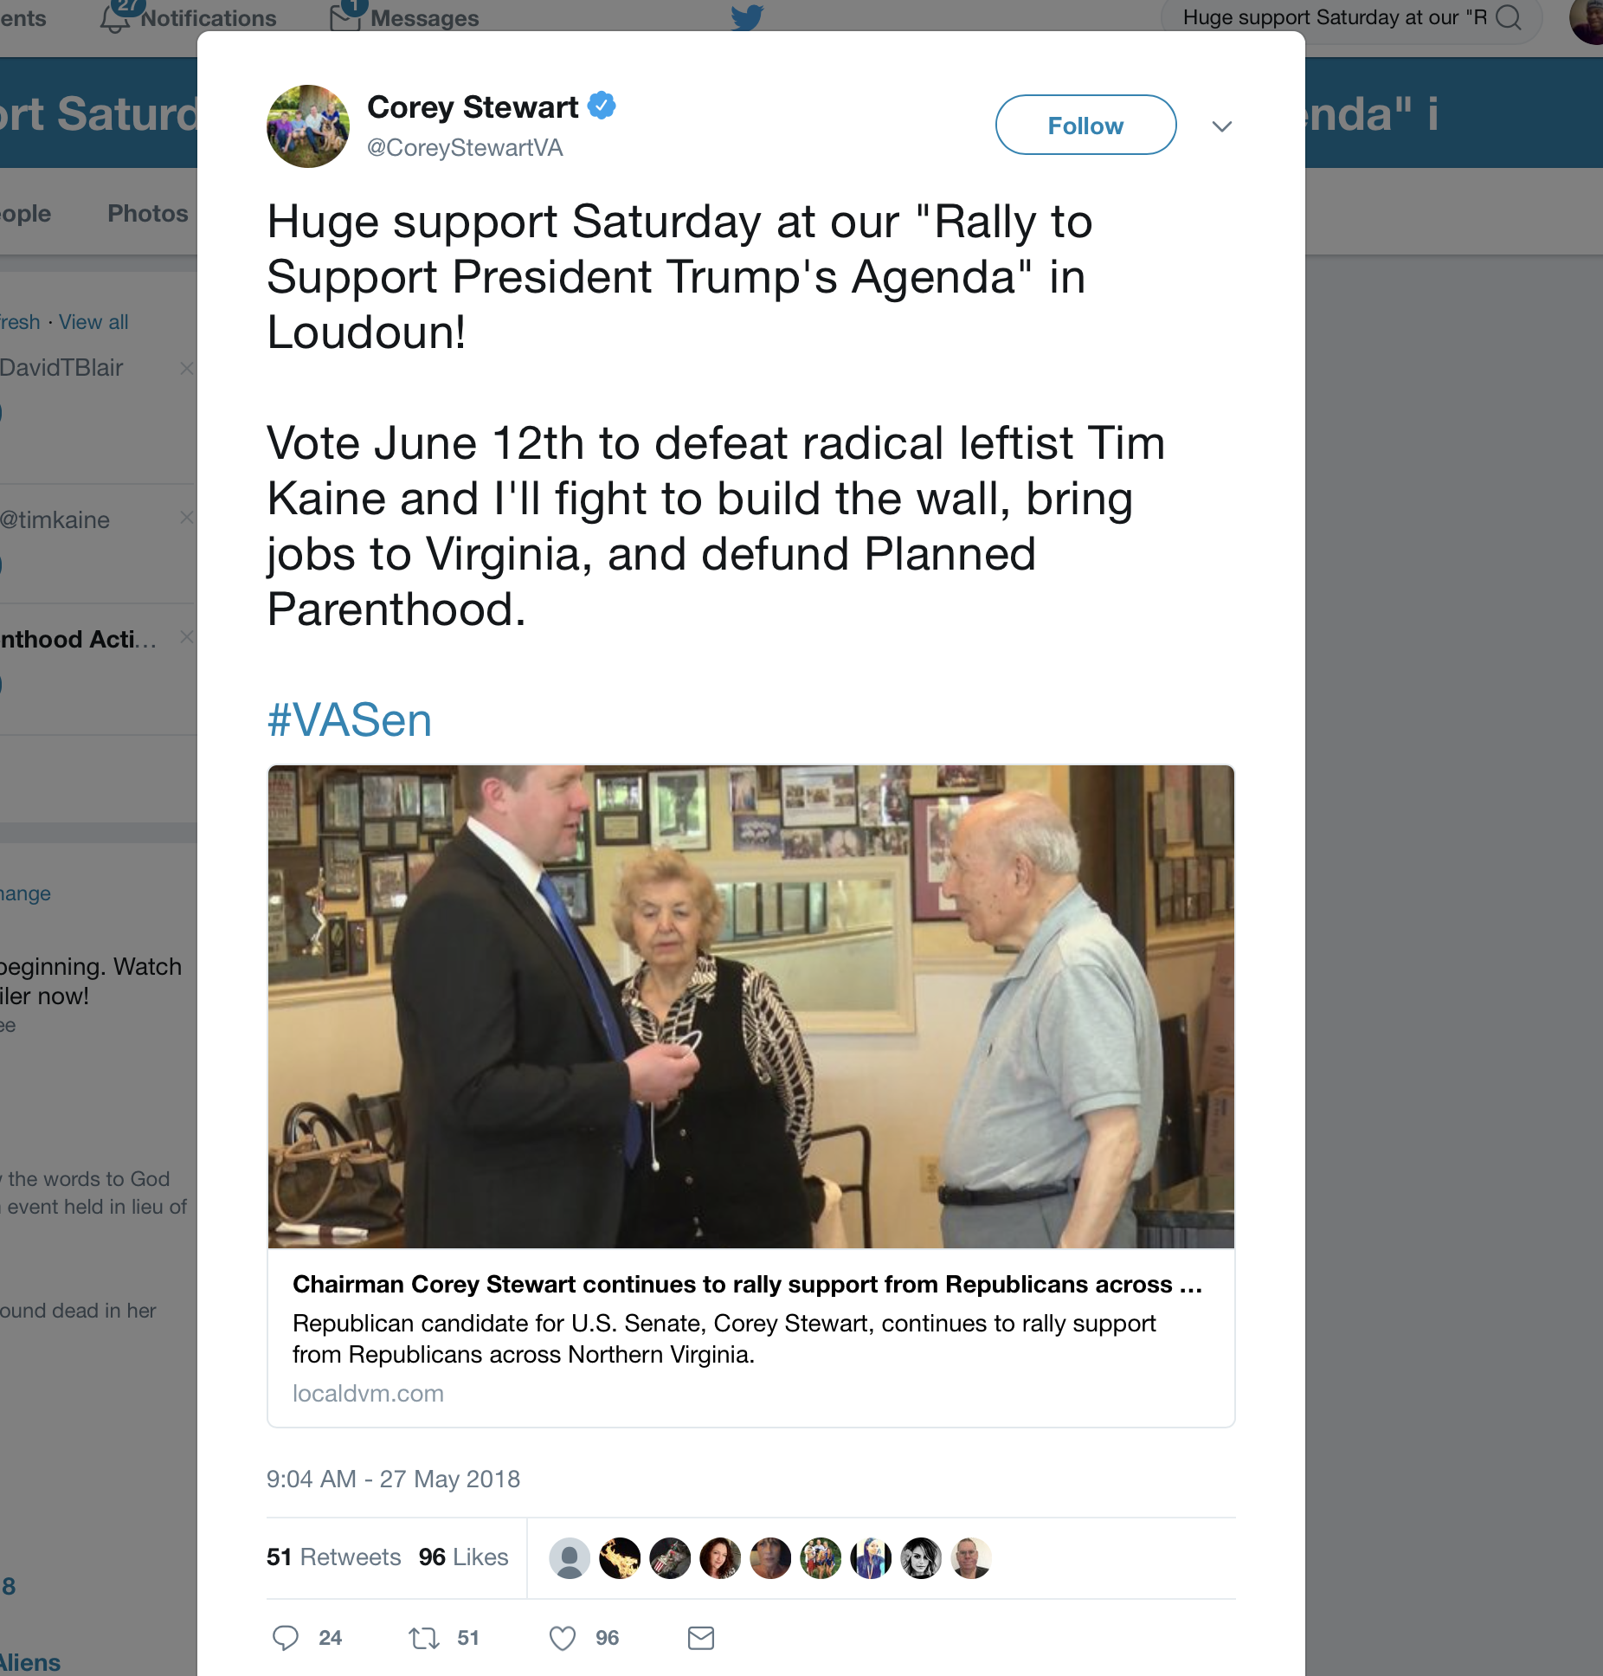

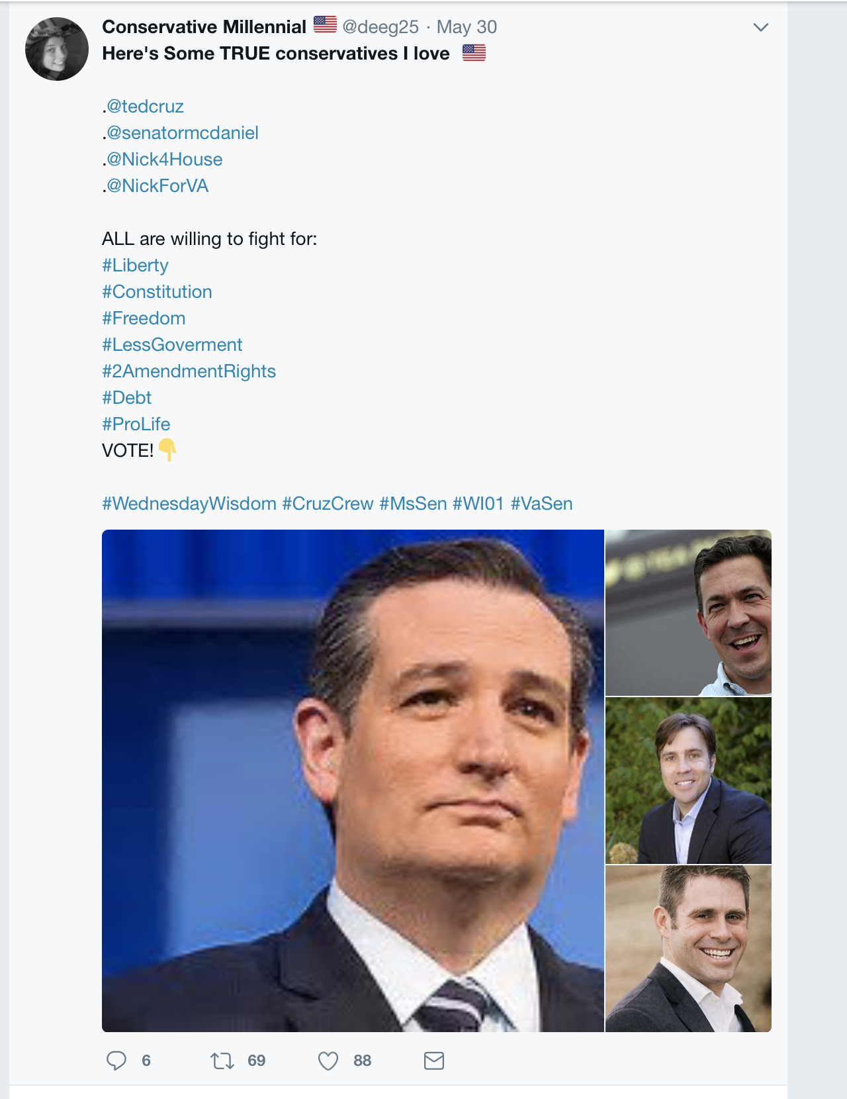

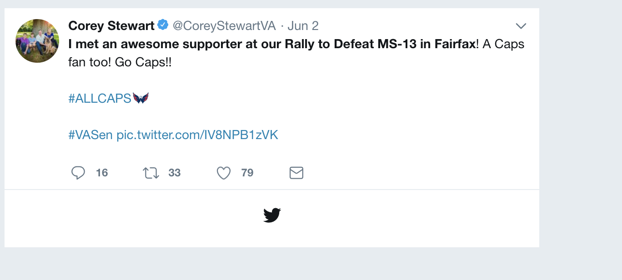

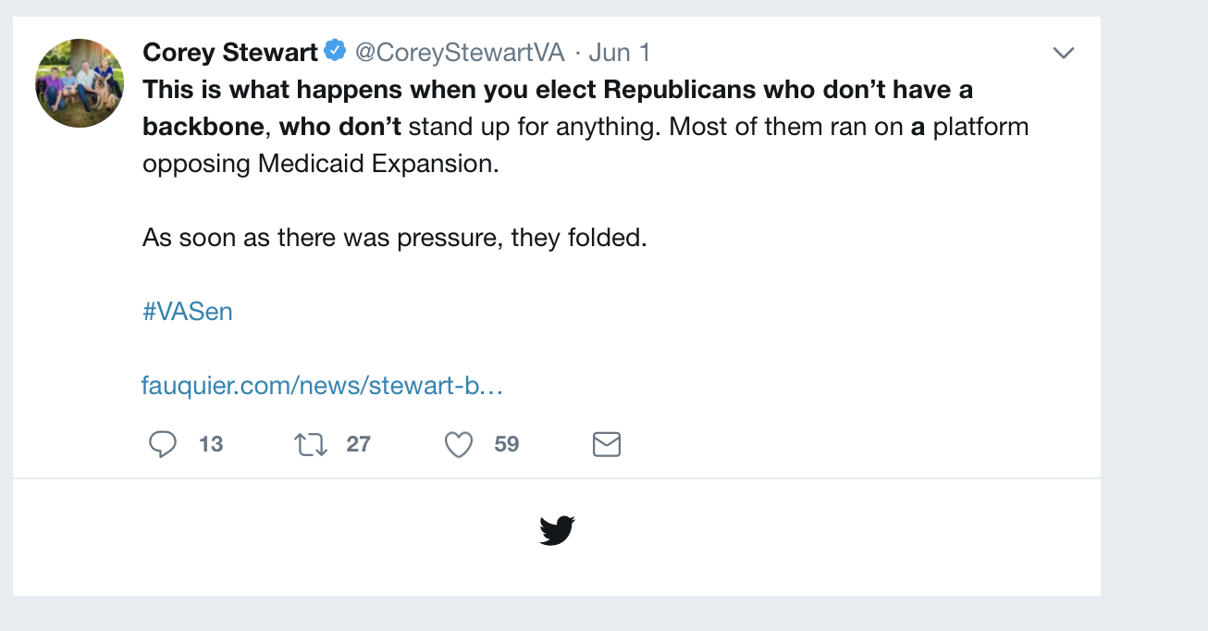

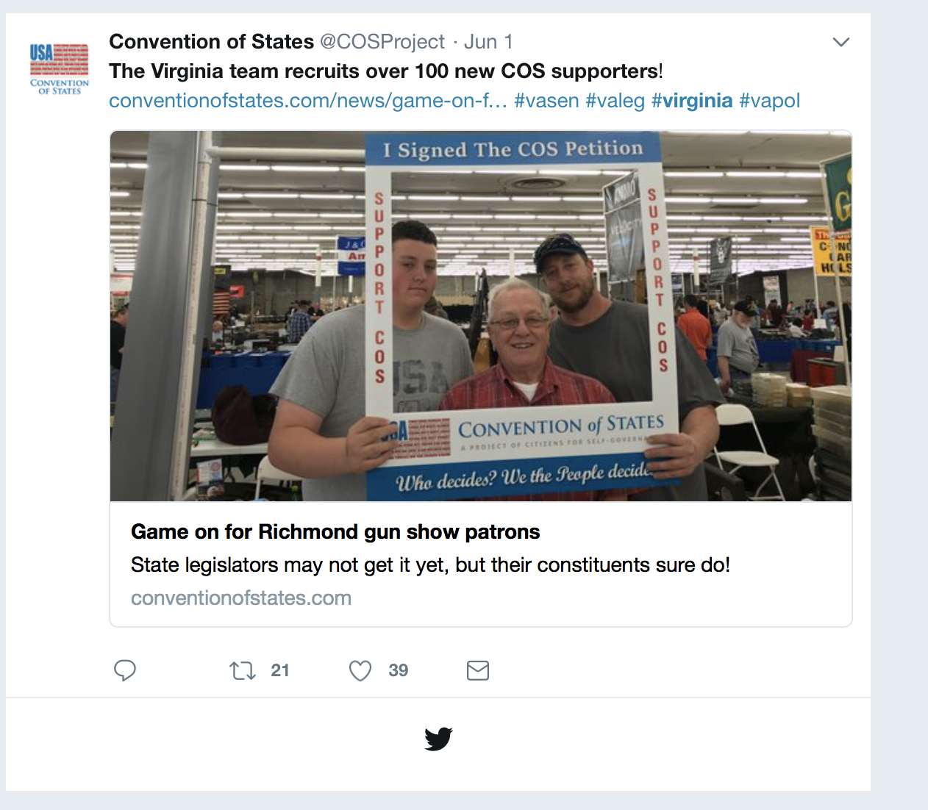

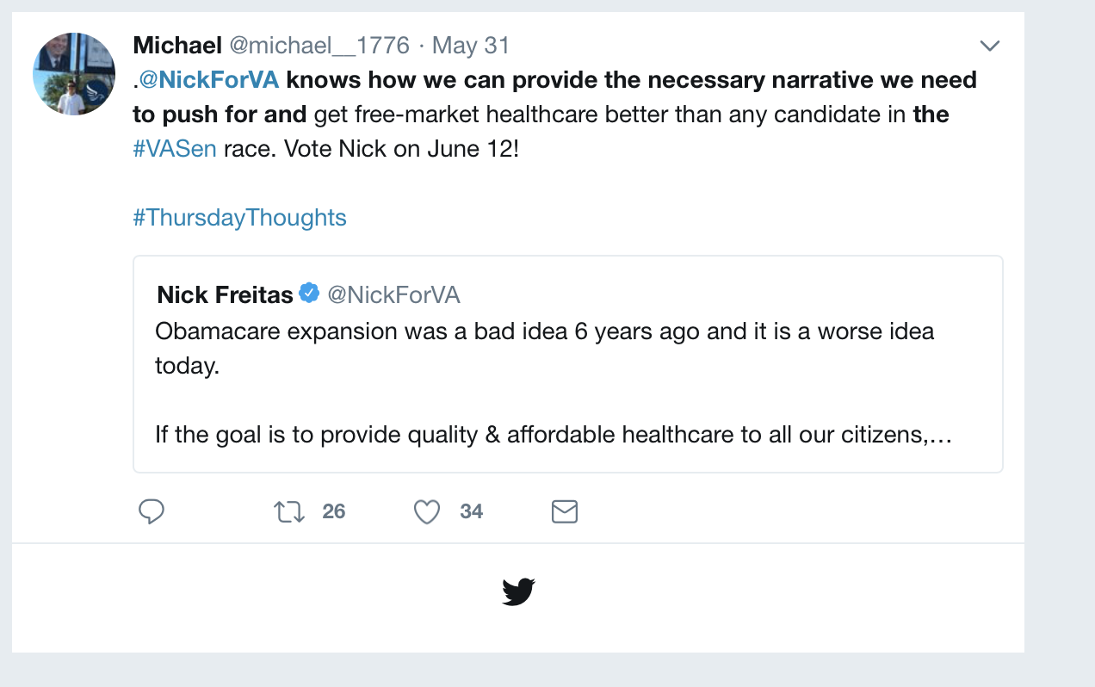

**Accounts dominating the Conversation**

These twitter handles have aggregated the most retweets out of all the tweets that they have sent out.

**accounts that have the most total Retweets**

These twitter handles have aggregated the most retweets out of all the tweets that they have sent out.

## screenName Total_RT  
## CoreyStewartVA 122  
## deeg25 69  
## michael__1776 26  
## COSProject 21  
## VA_GOP 20  
## IanSams 4

**Most Active Accounts (including Retweets)**

These twitter handles have sent out the most tweets during the week (Including tweets)

## Var1 Freq  
## Croatansound 7  
## michael__1776 5  
## constitutionmd 4  
## CoreyStewartVA 4  
## eugenedelgaudio 4  
## GarrenShipley 4

**Most Active Accounts**

These twitter handles have sent out the most tweets during the week.

## Var1 Freq  
## Croatansound 5  
## CoreyStewartVA 4  
## GarrenShipley 3  
## michael__1776 2  
## TweetrHandle 2  
## CATargetBot 1

**VISUALIZATION**

#WORDCLOUD of most common used words

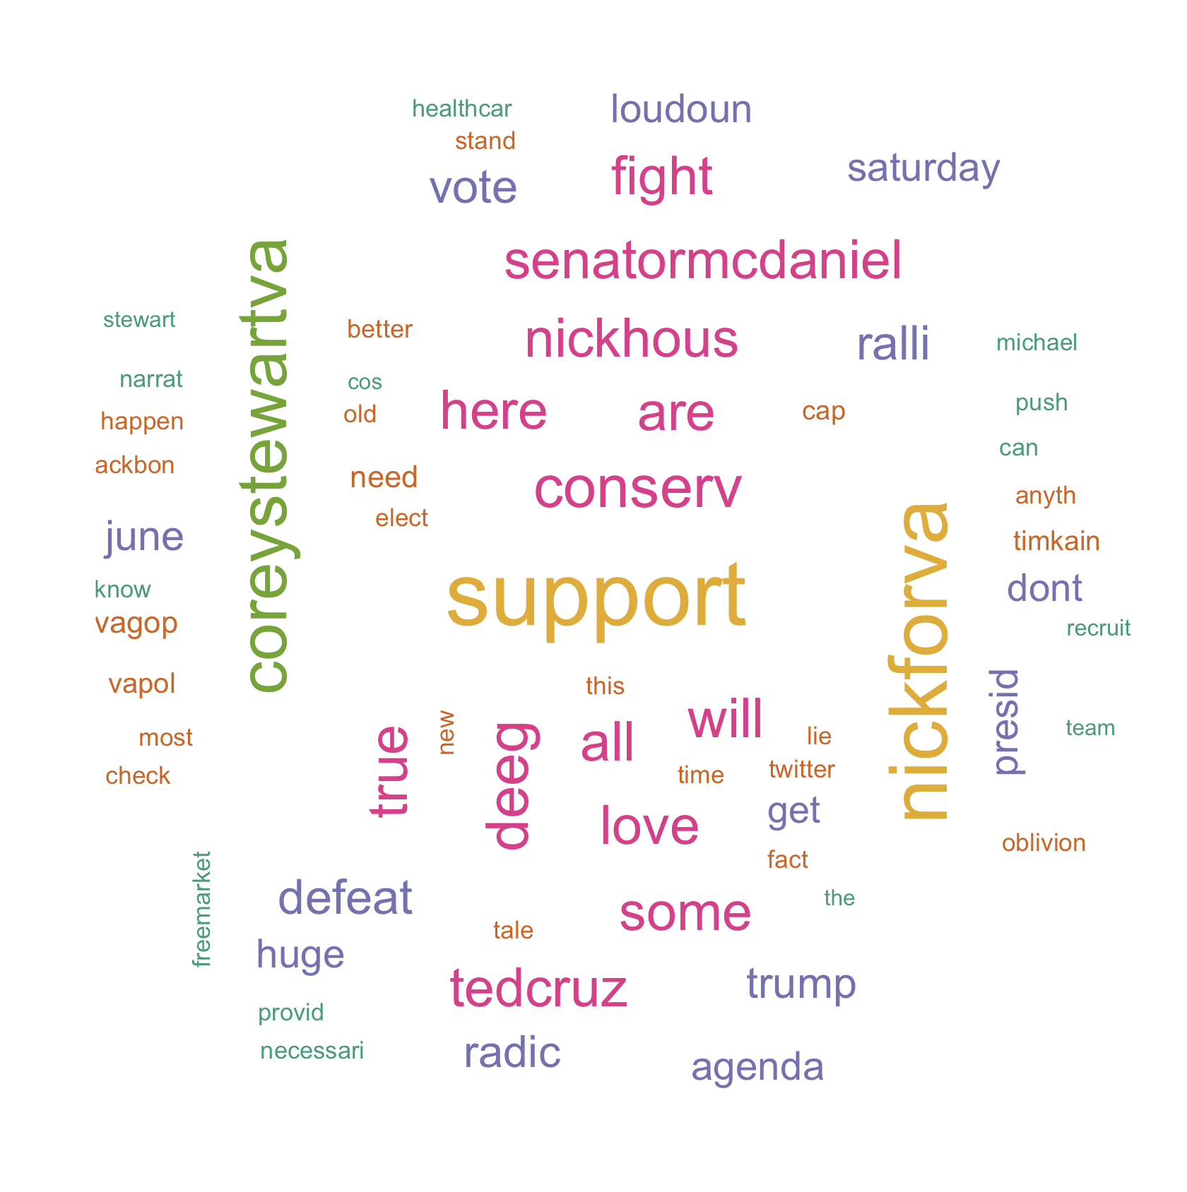

# List of The Top Ten Frequently used Words

## word freq  
## support support 121  
## nickforva nickforva 107  
## coreystewartva coreystewartva 87  
## conserv conserv 74  
## deeg deeg 73  
## all all 67  
## will will 67  
## are are 66  
## here here 66  
## love love 66

# Plot of Words that Appear at least 25 times

##   
## Attaching package: 'ggplot2'

## The following object is masked from 'package:NLP':  
##   
## annotate

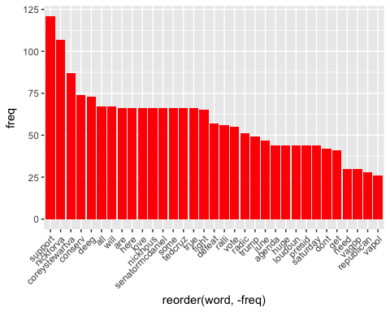

## Words Associated with coreystewartva and nickforva

To find out what words are associated with the candidates, I use a function called FindAssocs() on the dataset. For any given word, findAssocs() calculates its correlation with every other word in the dataset. Scores range from 0 to 1. A score of 1 means that two words always appear together, while a score of 0 means that they never appear together.

# which words are associated with "Corey Stewart"  
   
 findAssocs(tdm,"coreystewartva", 0.1)

## $coreystewartva  
## ralli defeat radic agenda huge loudoun   
## 0.71 0.70 0.68 0.62 0.62 0.62   
## presid saturday support june trump vote   
## 0.62 0.62 0.61 0.59 0.56 0.50   
## anyth backbon dont elect happen most   
## 0.39 0.39 0.39 0.39 0.39 0.39   
## stand this republican allcap awesom cap   
## 0.39 0.39 0.29 0.28 0.28 0.28   
## fairfax fan met vas anoth correct   
## 0.28 0.28 0.28 0.24 0.21 0.21   
## eras gone histori indic left polit   
## 0.21 0.21 0.21 0.21 0.21 0.21   
## rampant addit creat full repeal want   
## 0.21 0.20 0.20 0.20 0.20 0.20   
## weve just dependen iansam let medicaid   
## 0.20 0.18 0.18 0.18 0.16 0.15

findAssocs(tdm,"nickforva", 0.1)

## $nickforva  
## conserv deeg are here   
## 0.76 0.75 0.71 0.71   
## love nickhous senatormcdaniel some   
## 0.71 0.71 0.71 0.71   
## tedcruz true all fight   
## 0.71 0.71 0.70 0.70   
## will need can freemarket   
## 0.68 0.44 0.35 0.35   
## healthcar know narrat necessari   
## 0.35 0.35 0.35 0.35   
## provid push michael better   
## 0.35 0.35 0.34 0.29   
## real libertyris antoniaokafor nickva   
## 0.24 0.24 0.22 0.22   
## patriot america addit creat   
## 0.22 0.19 0.17 0.17   
## full repeal want weve   
## 0.17 0.17 0.17 0.17   
## build chanc del grandstand   
## 0.15 0.15 0.15 0.15   
## last now run dependen   
## 0.15 0.15 0.15 0.15   
## iansam frankoanderson medicaid pleas   
## 0.15 0.13 0.12 0.12   
## deal guy heard hes   
## 0.11 0.11 0.11 0.11   
## larryoconnor today   
## 0.11 0.11

findAssocs(tdm,"ewjacksonsr",0.1 )

## $ewjacksonsr  
## integr make ounc public rpv someon still wait recruit   
## 1.00 1.00 1.00 1.00 1.00 1.00 1.00 1.00 0.23

**#VASen tweets per day**

